Laboratory 18: Transistors
(Edit this document as needed)

Partner 1: John Gonzaelz

Partner 2: Saaif Ahmed

Part A
Brief description of the Transistor experiment:

Observing and analyzing transistor behavior in a circuit and drawing conclusions about how each pin of the transistor works.

Approximately, what is the forward voltage of a diode when it is ‘on’ (allowing current flow)?

V_{Don} | .7 [V]

Ideally, what is the current through a diode when reverse biased (‘off’)?

I_{Doff} | 0 [A]

Plot of the base voltage (V_{B}) and collector voltage (V_{C}) vs. time, with annotations as indicated in the laboratory. (Discovery Board)

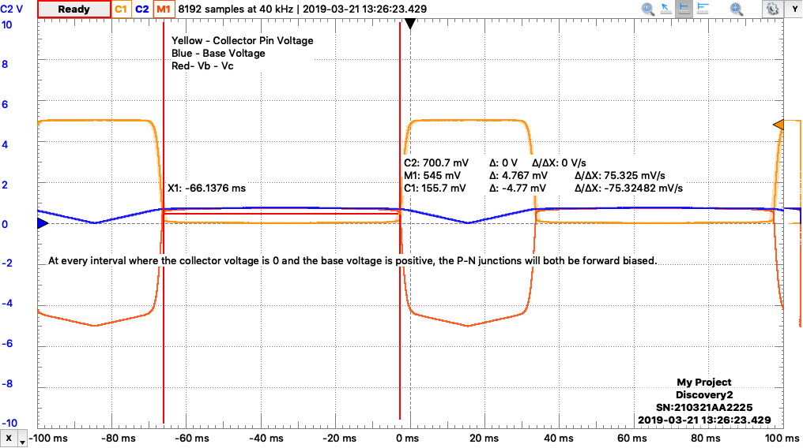

Using Ohm’s Law for R1 [I_{R1} = (VDC – V_{collector})/R1] determine the collector current when the collector voltage is a maximum, V_{Cmax}

I_{Coff} | 0 [mA]

Using Ohm’s Law for R1 [I_{R1} = (VDC – V_{collector})/R1] determine the collector current when the collector voltage is a minimum, V_{Cmin}

I_{Coon} | 5 [mA]

Measure the collector emitter voltage (V_{CE}) when the current through the transistor is a maximum (when V_{C} = V_{Cmin}).

V_{CE} | .743 [V]

Does your above answer agree with expectations that both diodes are ‘on’?

Yes

When the input voltage (Vsource) is at a maximum, is the collector voltage at its maximum or its minimum?

Minimum

When the input voltage (Vsource) is at a minimum, is the collector voltage at its maximum or its minimum?

Maximum
Part B
Brief description of the Transistor simulation experiment:
The objective of the simulation is to verify that the experiment conducted within the previous part is valid and within reasonable error. The circuit is built again in LTSpice and the same data is collected as before to simulate working with ideal components.

Plot of the base voltage (V_{B}) and collector voltage (V_{C}) vs. time, with annotations as indicated in the laboratory. (LTspice)
Black: Collector
Blue: Base
Both junctions are forward biased when the Collector (Black) is 0V
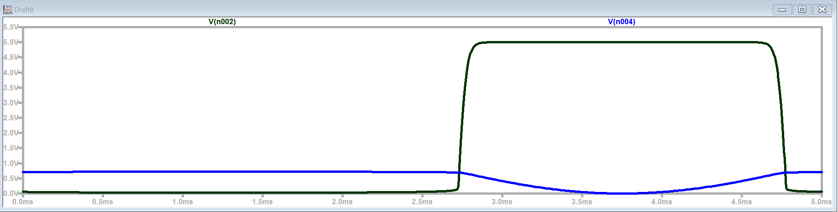

Plot of the base collector voltage (V_{BC} = V_{B} – V_{C}). (LTspice)

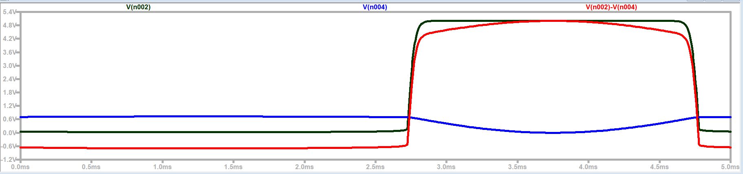
Red: V_{BC}

Using Ohm’s Law for R1 [I_{R1} = (VDC – V_{collector})/R1] determine the collector current when the collector voltage is a maximum, V_{Cmax}

I_{Coff} | 0[A]

Using Ohm’s Law for R1 [I_{R1} = (VDC – V_{collector})/R1] determine the collector current when the collector voltage is a minimum, V_{Cmin}

I_{Coon} | 0.005[A]

Measure the collector emitter voltage (V_{CE}) when the current through the transistor is a maximum (when V_{C} = V_{Cmin}).

V_{CE} | 0.006[V]

Does your above answer agree with expectations that both diodes are ‘on’?
Yes

When the input voltage (Vsource) is at a maximum, is the collector voltage at its maximum or its minimum?
Minimum

When the input voltage (Vsource) is at a minimum, is the collector voltage at its maximum or its minimum?
Maximum

Verification of LTspice transistor results by a TA/Instructor. ______jb 3/25_______

Part C
Brief description of Output Impedance experiment:

Measuring the output voltage of the voltage source as R2 decreases in value and calculating the Thevenin resistance.

Replace R2 with various loads and measure the voltage across R2. (Discovery Board)

RLoad value | Vout (V_{C})
1MΩ | 5 V
100kΩ | 5 V
10kΩ | 4.5 V
1kΩ | 2.5 V
100Ω | 0.45 V
10Ω | 50 mV

Using the 1MΩ result, identify the Thevenin voltage. (This question is equivalent to problem 3 on Quiz 1)

V_{Th} | 5[V]

Using an RLoad value where the output is between maximum and minimum values, identify the Thevenin resistance. (This question is equivalent to problem 3 on Quiz 1)

R_{Th} | 1k[Ω]

Verification of Thevenin results by a TA/Instructor. ___________YL________________

Part E
Brief discussion on how a transistor can be used as a switch why that is useful. Provide an example in a practical setting.

A transistor can be used as an active switch component because based on the voltage of the base and collector, the transistor will become forward or backwards biased. When the transistor is forward biased, the circuit will flow forward normally. When the transistor is backwards biased, the circuit will see not positive voltage drop and no energy will flow until the voltage of the collector pin is increased.

Provide a brief description of how this experiment related to and/or helped you understand an earlier experiment.

This experiment helped with my understanding of voltage dividers and seeing how when the voltage between two resistors in series decreases, the circuit becomes closer to becoming shorted.

